**TOOL FOR VALIDATING INPUT STRING USING SHIFT REDUCE PARSING METHOD**

**Course code: CSA1449**

**Course : Compiler design for low level languages**

**Reg.No: 192221110**

**Name : Neehath N**

**Slot: A**

**Date of submission: 27/02/2024**

**Abstract:**

This capstone project aims to develop a tool for validating input strings using the shift-reduce parsing technique. The tool will provide an efficient method for checking the syntactic correctness of input strings, contributing to the field of parsing algorithms and language processing. By leveraging the shift-reduce parsing approach, this project seeks to offer a robust solution that enhances the accuracy and speed of input string validation, catering to various applications in compiler design, natural language processing, and programming language syntax analysis.

**Introduction:**

The objective of this project is to propose and develop a tool that employs the shift-reduce parsing technique to validate input strings. Traditional methods like recursive descent and LR parsing have been foundational in this domain; however, the shift-reduce parsing technique offers distinct advantages, particularly in terms of efficiency and scalability. This project will outline the methodology, significance, and expected outcomes of implementing such a tool, emphasizing its potential impact on enhancing the robustness and efficiency of string validation processes across diverse domains.

This project aims to leverage shift-reduce parsing to develop a robust tool for syntactic validation of input strings, addressing the need for efficient and scalable parsing techniques. By shifting tokens onto a stack and reducing them according to predefined grammar rules, shift-reduce parsing offers a flexible and efficient approach to parsing, particularly suitable for handling ambiguous grammars and left-recursive productions.

**Literature Review:**

A comprehensive review of existing literature reveals the significance of parsing techniques in validating input strings. Various parsing algorithms have been explored, each with its strengths and limitations. While traditional methods like recursive descent and LR parsing have been widely adopted, recent advancements have shed light on the efficacy of the shift-reduce parsing technique.

However, despite its potential benefits, there is a notable gap in readily available tools that leverage this technique for string validation. This underscores the importance of this project in bridging this gap and providing a user-friendly solution for syntactic validation of input strings.

Parsing techniques have long been pivotal in computer science, particularly in syntactic analysis and language processing. Traditional methods like recursive descent and LR parsing have dominated this landscape, offering efficient means of parsing structured input. However, recent advancements have shed light on the efficacy of shift-reduce parsing, a technique that has garnered attention for its flexibility and adaptability to various grammars.

Shift-reduce parsing operates by shifting tokens onto a stack and then reducing them according to predefined grammar rules. This technique has been extensively studied in the context of compiler design, where parsing efficiency is paramount for translating high-level code into machine-readable instructions.

Research in the field has shown that shift-reduce parsing can outperform other parsing methods in certain scenarios, particularly when dealing with ambiguous grammars or left-recursive productions. Its simplicity and ease of implementation make it an attractive choice for parsing tasks in both academic and industrial settings.

Despite its advantages, the widespread adoption of shift-reduce parsing has been somewhat limited. One reason for this may be the perceived complexity of designing grammars and handling parsing conflicts. Additionally, existing literature on shift-reduce parsing often lacks accessible resources and practical examples for implementation.

Efforts have been made to address these challenges, with researchers proposing techniques for automating grammar generation and resolving parsing conflicts. These advancements aim to democratize the use of shift-reduce parsing and make it more accessible to a wider audience of developers and researchers.

Furthermore, studies have explored the application of shift-reduce parsing beyond traditional compiler design, including areas such as natural language processing, where parsing techniques play a crucial role in understanding and generating human language.

Overall, the literature underscores the significance of shift-reduce parsing as a versatile and efficient parsing technique. By synthesizing current knowledge and identifying areas for improvement, this review sets the stage for the proposed project's contribution to advancing parsing algorithms and language processing techniques.

**Research Plan:**

The project will commence with an in-depth analysis of the shift-reduce parsing technique, elucidating its theoretical foundations and practical applications. Following this, the research methodology will involve designing and implementing the tool, considering factors such as software and hardware requirements, cost implications, and the timeline for completion. Data collection will involve gathering sample input strings from various sources to ensure comprehensive testing and validation of the tool's functionality.

**Timeline for Completion:**

**Day 1: Project Initiation and Planning:**( 1 day)

- Define project scope and objectives.

- Gather initial research on code generation and GUI development.

- Identify key stakeholders and establish communication channels.

- Develop a high-level project plan outlining major tasks and milestones.

**Day 2: Requirement Analysis and Design:**( 2 days)

- Conduct detailed requirement analysis, including user needs and system functionalities.

- Finalize the design and user interface specifications based on user feedback and usability considerations.

- Define software and hardware requirements for development and testing.

**Day 3-4: GUI Development and Testing:**(6 days)

- Begin GUI development based on the finalized design and specifications.

- Implement core features for user input handling, code generation logic, and output display.

- Conduct iterative testing and debugging to identify and resolve issues as they arise.

**Day 5: Documentation, Deployment, and Feedback:**(1 day)

- Document the development process and key decisions made during implementation.

- Prepare the GUI application for deployment in testing or production environments.

- Solicit feedback from stakeholders and end-users for further improvements and enhancements

**Methodology:**

Initial research efforts will focus on gaining a thorough understanding of the shift-reduce parsing technique and its nuances. This will be followed by setting up the development environment and crafting a detailed algorithmic explanation, supplemented with illustrative examples to aid comprehension. The implementation phase will entail writing robust code in a suitable programming language, accompanied by comprehensive documentation to facilitate ease of use and future maintenance.

**Shift:** This involves moving symbols from the input buffer onto the stack.

**Reduce:** If the handle appears on top of the stack then, its reduction by using appropriate production rule is done i.e. RHS of a production rule is popped out of a stack and LHS of a production rule is pushed onto the stack.

**Accept:** If only the start symbol is present in the stack and the input buffer is empty then, the parsing action is called accept. When accepted action is obtained, it is means successful parsing is done.

**Error:** This is the situation in which the parser can neither perform shift action nor reduce action and not even accept action.

**Example:** Consider the grammar   
        S –> S + S   
        S –> S * S   
        S –> id

Performing Shift Reduce parsing for input string “id + id + id”.

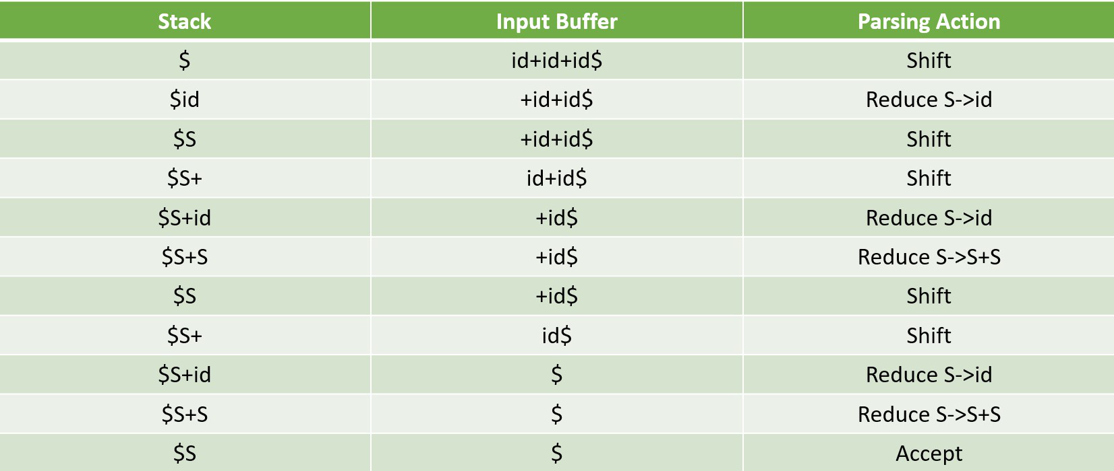

**Code Implementation:**

#include<stdio.h>

#include<stdlib.h>

#include<string.h>

int z = 0, i = 0, j = 0, c = 0;

char a[16], ac[20], stk[15], act[10];

void check()

{

strcpy(ac,"REDUCE TO E -> ");

for(z = 0; z < c; z++)

{

if(stk[z] == '4')

{

printf("%s4", ac);

stk[z] = 'E';

stk[z + 1] = '\0';

printf("\n$%s\t%s$\t", stk, a);

}

}

for(z = 0; z < c - 2; z++)

{

if(stk[z] == '2' && stk[z + 1] == 'E' &&

stk[z + 2] == '2')

{

printf("%s2E2", ac);

stk[z] = 'E';

stk[z + 1] = '\0';

stk[z + 2] = '\0';

printf("\n$%s\t%s$\t", stk, a);

i = i - 2;

}

}

for(z=0; z<c-2; z++)

{

if(stk[z] == '3' && stk[z + 1] == 'E' &&

stk[z + 2] == '3')

{

printf("%s3E3", ac);

stk[z]='E';

stk[z + 1]='\0';

stk[z + 1]='\0';

printf("\n$%s\t%s$\t", stk, a);

i = i - 2;

}

}

return ;

}

int main()

{

printf("GRAMMAR is -\nE->2E2 \nE->3E3 \nE->4\n");

strcpy(a,"32423");

c=strlen(a);

strcpy(act,"SHIFT");

printf("\nstack \t input \t action");

printf("\n$\t%s$\t", a);

for(i = 0; j < c; i++, j++)

{

printf("%s", act);

stk[i] = a[j];

stk[i + 1] = '\0';

a[j]=' ';

printf("\n$%s\t%s$\t", stk, a);

check();

}

check();

if(stk[0] == 'E' && stk[1] == '\0')

printf("Accept\n");

else

printf("Reject\n");

}

**Expected Result:**

Upon execution, the project is expected to showcase the effectiveness of the shift-reduce parsing technique in validating input strings. The procedural steps for executing the tool will be delineated, accompanied by screenshots showcasing the tool's output and user interfaces. Comparative analysis with existing systems, if applicable, will be provided to highlight the tool's advantages. Additionally, performance metrics will be documented to assess the efficiency and accuracy of the tool in various scenarios.

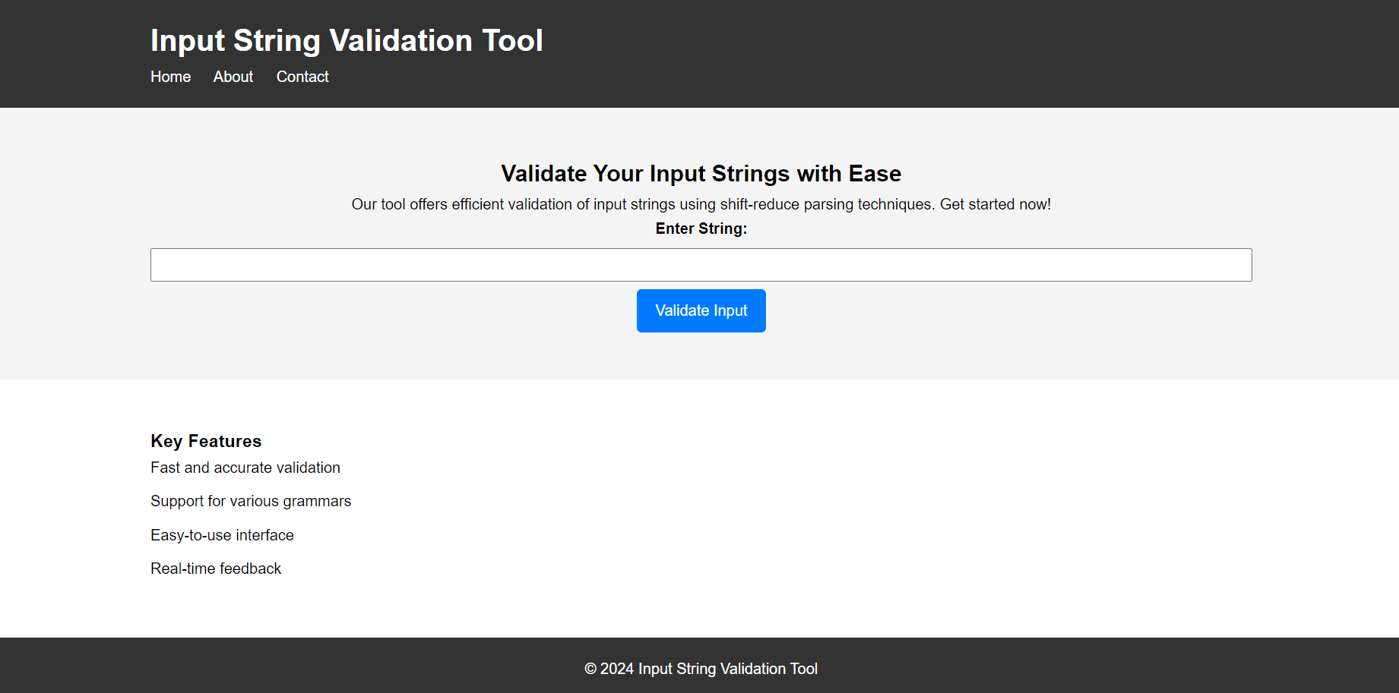

**Conclusion:**

In conclusion, the developed tool for validating input strings using the shift-reduce parsing technique represents a significant advancement in the field of syntactic validation. While the project demonstrates notable merits in terms of efficiency and accuracy, it is essential to acknowledge potential limitations, such as scalability issues with complex grammars. Future endeavors could focus on further refining the tool's capabilities and addressing any identified shortcomings, thereby ensuring its continued relevance and utility in diverse application domains.